**PJ 10 Report My Name: _Yaowei Lei_**

**A. The following is my Python source program:**

**// Please copy your source program into here from your Visual Studio IDE.**

**// Your code here must be in color. You must not show screen prints here.**

#-----------------------------------------------------------------------------------------------------------.

# Author: Yaowei Lei

# Date: 12/08/2021

# Purpose: CS119-PJ10: Tic-Tac-Toe Game Check – check 9 tic-tac-toe game and show all its winning result in detail

#-----------------------------------------------------------------------------------------------------------.

def show ( game ) :

print ("", game[0][0], game[0][1], game[0][2], "\n", game[1][0], game[1][1], game[1][2], "\n", game[2][0], game[2][1], game[2][2])

def checkwin ( game ) :

count = 0

player = [O, X]

for p in player :

if ( winrow1(game, p) ) :

print (p, "won by row 1")

count += 1

if ( winrow2(game, p) ) :

print (p, "won by row 2")

count += 1

if ( winrow3(game, p) ) :

print (p, "won by row 3")

count += 1

for p in player :

if ( wincol1(game, p) ) :

print (p, "won by column 1")

count += 1

if ( wincol2(game, p) ) :

print (p, "won by column 2")

count += 1

if ( wincol3(game, p) ) :

print (p, "won by column 3")

count += 1

for p in player :

if ( windia1(game, p) ) :

print (p, "won by diagonal 1")

count += 1

if ( windia2(game, p) ) :

print (p, "won by diagonal 2")

count += 1

if (count == 0) :

print ("It is a tie.")

def winrow1( t, p ): # show whether row1 wins for player p: 'X' or 'O'

r = 0 # for board row 1 # p can be ‘X’ or ‘O’ , t is the 3x3 game board

return (t[r][0]==t[r][1] and t[r][1]==t[r][2] and t[r][2]==p) # True | False # end of winrow1( )

def winrow2( t, p ): # show whether row2 wins for player p: 'X' or 'O'

r = 1 # for board row 2 # p can be ‘X’ or ‘O’ , t is the 3x3 game board

return (t[r][0]==t[r][1] and t[r][1]==t[r][2] and t[r][2]==p) # True | False # end of winrow2( )

def winrow3( t, p ): # show whether row3 wins for player p: 'X' or 'O'

r = 2 # for board row 3 # p can be ‘X’ or ‘O’ , t is the 3x3 game board

return (t[r][0]==t[r][1] and t[r][1]==t[r][2] and t[r][2]==p) # True | False # end of winrow3( )

def wincol1( t, p ): # show whether col1 wins for player p: 'X' or 'O'

c = 0 # for board col 1 # p can be ‘X’ or ‘O’ , t is the 3x3 game board

return (t[0][c]==t[1][c] and t[1][c]==t[2][c] and t[2][c]==p) # True | False # end of wincol1( )

def wincol2( t, p ): # show whether col2 wins for player p: 'X' or 'O'

c = 1 # for board col 2 # p can be ‘X’ or ‘O’ , t is the 3x3 game board

return (t[0][c]==t[1][c] and t[1][c]==t[2][c] and t[2][c]==p) # True | False # end of wincol2( )

def wincol3( t, p ): # show whether col3 wins for player p: 'X' or 'O'

c = 2 # for board col 3 # p can be ‘X’ or ‘O’ , t is the 3x3 game board

return (t[0][c]==t[1][c] and t[1][c]==t[2][c] and t[2][c]==p) # True | False # end of wincol3( )

def windia1( t, p ): # show whether diagonal1 wins for player p: 'X' or 'O'

return (t[0][0]==t[1][1] and t[1][1]==t[2][2] and t[2][2]==p) # end of windia1( )

def windia2( t, p ): # show whether diagonal2 wins for player p: 'X' or 'O'

return (t[0][2]==t[1][1] and t[1][1]==t[2][0] and t[2][0]==p) # end of windia2( )

# MAIN PROGRAM: ================================================.

n = 1 # line number for each separator line

print ("Welcome to the TicTacToe Game Check of \"Yaowei lei\"!")

print (n,"============================================================"); n+=1;

O = 'O' # player O

X = 'X' # player X

tlist = [ [ [O,O,O], # Game 1 # tlist [ 0 ] to get this game

[O,O,O], # tlist is like a 3-dimensional array or list

[O,O,O] ] ,

[ [X,X,X], # Game 2 # tlist [ 1 ] to get this game

[X,X,X],

[X,X,X] ] ,

[ [X,O,X], # Game 3 # tlist [ 2 ] to get this game

[X,X,O],

[X,O,O] ] ,

[ [X,O,O], # Game 4 # tlist [ 3 ] to get this game

[O,X,O],

[X,X,O] ] ,

[ [X,O,X], # Game 5 # tlist [ 4 ] to get this game

[O,X,O],

[X,O,O] ] ,

[ [O,X,O], # Game 6 # It is a tie. # tlist [ 5 ] to get this game

[X,O,X],

[X,O,X] ] ]

for i in range(0, 6): # 6 games to check one by one: 1 2 3 4 5 6

print("GAME", i+1 ," is as follows:")

show( tlist[i] ) # to show 3x3 game board

checkwin( tlist[i] ) # to check all 8 winning situations for both X and O players

print (n,"============================================================"); n+=1;

# More code to keep getting input from the user for the next game

while True :

G = [ [X,X,X], [X,X,X], [X,X,X] ] # G is a game board of 3x3

S = input("Please enter your game board (* to exit)>")

if (S == "*") :

break

else :

k = 0

for i in range(0, 3) :

for j in range(0, 3) :

G[i][j] = S[k]

k += 1

print("GAME", n-1 ," is as follows:")

show( G ) # to show 3x3 game board

checkwin( G ) # to check all 8 winning situations for both X and O players

print (n,"============================================================"); n+=1;

# Stop this program if user’s input is ‘*’

# Thank the user before exit

print (n,"============================================================"); n+=1;

print("Thank you for playing the TicTacToe Game Check of \"Yaowei lei\"!")

print (n,"============================================================"); n+=1;

# End of MAIN PROGRAM ============================================.

# End of Program ########################################

**B. The following is the console output of my 9 games:**

**// One way to copy the console output is to press Ctrl+Alt+PrtScn.**

**// Another way to copy is to use the snipping tool. To paste the image is to press Ctrl+v.**

**// The console display must not be too wide, otherwise it will be too hard to read once pasted.**

**// Please make sure your console is long enough to show all your output lines to be captured.**

**// Please copy your console output and paste into here. You complete output may have many parts.**

**Part 1:**

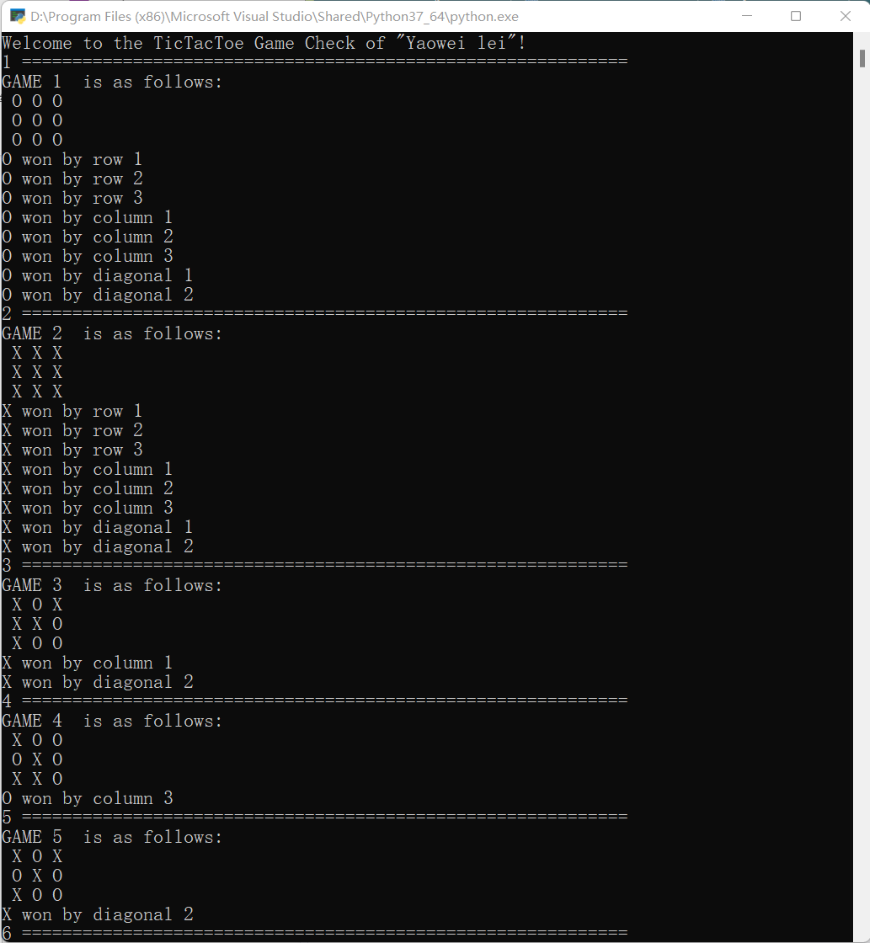

**Part 2:**

